Swimming relay

In a swimming relay race there are four team members and each one swims just one of the strokes: butterfly, backstroke, breaststroke or front-crawl.
You are the swimming coach for the Hungarian team in the Olympics, who should you choose for each stroke based on their current times in seconds?

 | Butterfly | Backstroke | Breaststroke | Front-crawl
Adam | 35 | 36 | 36 | 25
Boris | 31 | 31 | 35 | 23
Carl | 33 | 35 | 39 | 26
Dean | 32 | 38 | 33 | 24

Remember it is the fastest team that wins!

Hungarian Algorithm
 | Butterfly | Backstroke | Breaststroke | Front-crawl
Adam | 35 | 36 | 36 | 25
Boris | 31 | 31 | 35 | 23
Carl | 33 | 35 | 39 | 26
Dean | 32 | 38 | 33 | 24

Task 1
Adam’s fastest time is 25 seconds for the front-crawl. To compare his times across the strokes, you can subtract 25 from each value in the top row to give his relative times.
The same can be done for the other swimmers, in each case subtracting the smallest value in a row from every value in the row.
Complete the table:
 | Butterfly | Backstroke | Breaststroke | Front-crawl
Adam | 10 | 11 | 11 | 0
Boris | 8 | 8 | 12 | 0
Carl
Dean

Task 2
One swimmer must be allocated to breaststroke. Dean minimises the total additional time incurred by the team. So give Dean a 0 in breaststroke and and subtract 9 from the other breaststroke times.
 | Butterfly | Backstroke | Breaststroke | Front-crawl
Adam |  |  | 2 | 0
Boris |  |  | 3 | 0
Carl |  |  | 4 | 0
Dean |  |  | 0 | 0

It looks like Carl should do the butterfly. So give Carl a 0 in butterfly and complete the rest of the column.
Who should do the backstroke? Complete that column.
Who is left for the front-crawl?

Task 3

How long will it take the four swimmers in total to complete the relay?

Hungarian Algorithm on Excel

Can you create this on excel, using formulae for the middle two tables, so that if you change the numbers in the top table, the next two tables update:
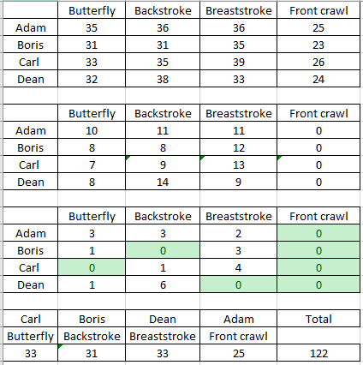

Useful functions

=MIN(B3:E3) will find the minimum of a set of numbers
=MIN($B$3:$E$3) means that this set of numbers won’t change as you drag down the formula to other cells. You can press F4 to get the dollar signs
You can use  to highlight the zeros

Answers

 | Butterfly | Backstroke | Breaststroke | Front-crawl
Adam | 35 | 36 | 36 | 25
Boris | 31 | 31 | 35 | 23
Carl | 33 | 35 | 39 | 26
Dean | 32 | 38 | 33 | 24

Task 1
 | Butterfly | Backstroke | Breaststroke | Front-crawl
Adam | 10 | 11 | 11 | 0
Boris | 8 | 8 | 12 | 0
Carl | 7 | 9 | 13 | 0
Dean | 8 | 14 | 9 | 0

Task 2
 | Butterfly | Backstroke | Breaststroke | Front-crawl
Adam | 3 | 3 | 2 | 0
Boris | 1 | 0 | 3 | 0
Carl | 0 | 1 | 4 | 0
Dean | 1 | 6 | 0 | 0

Task 3
Carl butterfly, boris backstroke, Dean breaststroke and Adam front-crawl
33+31+33+25 = 122

