Semi Circle Puzzle

**Introduction**

The solution to this puzzle was known by the Ancient Greeks. It is fun to try and solve by measurement, pattern spotting or by algebra.

Students could make a drawing of the shape and measure it to start with. Or they could create the shape on Geogebra using the instructions in the solution. Or they could work it out by adding in an extra line to the diagram and using Pythagoras.

**Solution**

Algebraically:

Adding in the centre of the circle and joining together points E and D you can see a right angled triangle:

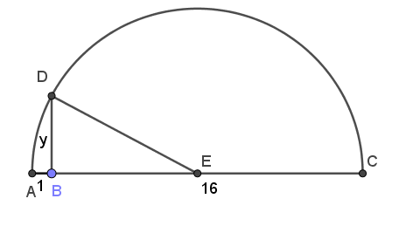We can use Pythagoras. First we know the radius is $\frac{(16+1)}{2}=8.5$. So the length DE is 8.5 and the length BE must be 7.5.

$${8.5}^{2}={7.5}^{2}+y^{2}$$

$${y^{2}=8.5}^{2}-{7.5}^{2}$$

$$y^{2}=16$$

$y=4$

For the general problem we have a radius of $\frac{(x+1)}{2}$, so length DE is $\frac{(x+1)}{2}$.

The length of BE $=\frac{(x+1)}{2}-1=\frac{x+1}{2}-\frac{2}{2}=\frac{x-1}{2}$

$${\left(\frac{x+1}{2}\right)}^{2}={\left(\frac{x-1}{2}\right)}^{2}+y^{2}$$

$$y^{2}={\left(\frac{x+1}{2}\right)}^{2}-{\left(\frac{x-1}{2}\right)}^{2}$$

$$y^{2}=\frac{x^{2}+2x+1}{4}-\left(\frac{x^{2}-2x+1}{4}\right)$$

$$y^{2}=\frac{4x}{4}$$

$$y^{2}=x$$

$$y=\sqrt{x}$$

On Geogebra

1.  Create a circle with centre at the origin (called ***A***) and radius 1 ( where a point ***B*** is on the circumference at [1,0])
2.  Add a number slider **a** ranging from min 2 to max 26
3. Type (a,0) into the input bar at the bottom of the screen to place a point ***C*** with coordinates (a,0) .
4.  Generate an arc ***d*** going through two points A and C (in the drop down menu 6th tool option from the left)
5.  Make a line ***e*** perpendicular to the x-axis going through ***B***
6. At the intersection of this arc and this new line, add a point ***D***
7.  Join B and D together using the segment tool from the 3rd drop down menu from the left.
8.  Then join A and C together
9. Your algebra view will look something like this

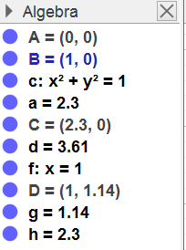

You can click on the blue circles to hide objects. Hide the circle c, and hide the line f.

1.  Click on the the length tool and click on B then D. The length of this segment (1) should appear.
2. Then measure the length BC. This should also be 1.
3.  You can now use the move tool to adjust the slider so that you can see how BD changes as you change the diameter of the semicircle. What do you notice?