Geogebra instructions for Chaos Game

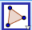 Use the polygon tool to draw a triangle.

You can right click on a vertex and select “Object Properties” to change the colour.
Change them so that you have red, blue, green.

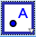 Make a new point inside the triangle

And then type the following into the Input Bar:

RandomBetween(1, 3)

This will give you a random integer between 1 and 3. If you press Ctrl+R it will refresh and give you a new number (or the same one!)

Use this icon to make a new textbox. Type in “Move halfway to blue”. Then, with the selected, right click on the text you have written and choose “Object Properties”. Go to the Advanced tab and type d=1 into the Condition to Show Object box (or whatever letter your random number has been stored under). Then click in any other box and then close the box with the red cross. Then try pressing Ctrl+R a few times to see what happens.

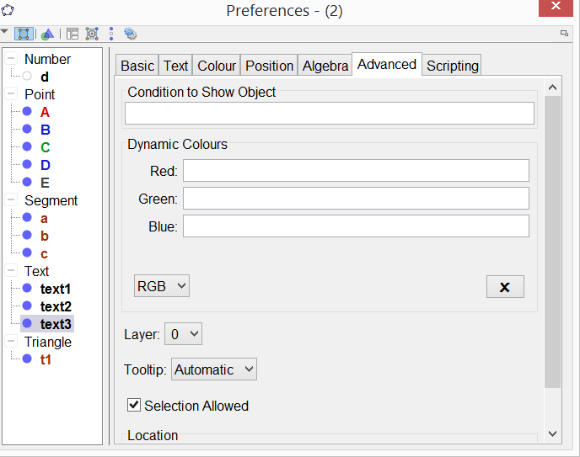

Make this work for red and green too.

You can now use the midpoint 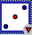 tool to play the game on Geogebra, following your own instruction pressing Ctrl+R each time!

Automatically on Geogebra!

In a new window do the following:
- Create a slider
- Create the point P and set its trace on. Make P size 1 by right clicking on object properties.
- Create the triangle ABC.
- Right click on the slider and go to "Object properties". Add this piece of code to the Scipting > On Update setting for the slider: T=If[RandomBetween[1,3]==1,A,If[RandomBetween[1,2]==1,B,C]] P=Midpoint[T,P]
- Right click on slider to animate it.
- Does it work perfectly? If not, can you change the code to make it work.

