Monday's child is fair of face,
Tuesday's child is full of grace,
Wednesday's child is full of woe,
Thursday's child has far to go,
Friday's child is loving and giving,
Saturday's child works hard for a living,
But the child who is born on the Sabbath day
Is fair and wise and good in every way.

Formula for the day of the week
Use the formula to find out (or confirm!) what day of the week you were born on, or a particular event in history.
You will need to work in mod 7. What this means is your answer must be between 0 and 6. You find the answer by dividing by 7 – the answer is the remainder.
e.g. (52 + 5) mod 7 = 1
because 52 + 5 = 57 and 57 divided by 7 is 8 remainder 1.
You also need to know that , is called the floor function. The floor function gives the largest integer less than or equal to .
e.g. $\left\lfloor 16.8\right\rfloor$ = 16
and $\left\lfloor 16\right\rfloor$ = 16

Zeller’s algorithm
In Zeller’s algorithm, the months are numbered from 3 for March to 14 for February. The year is assumed to begin in March; this means, for example, that January 1995 is to be treated as month 13 of 1994. The formula for the Gregorian calendar is
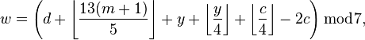
where
- Y is the year minus 1 for January or February, and the year for any other month
- y is the last 2 digits of Y
- c is the first 2 digits of Y
- d is the day of the month (1 to 31)
- m is the shifted month (March=3,...February=14)
- w is the day of week (1=Sunday,..0=Saturday)
https://en.wikipedia.org/wiki/Zeller%27s_congruence
Easter Sunday algorithm
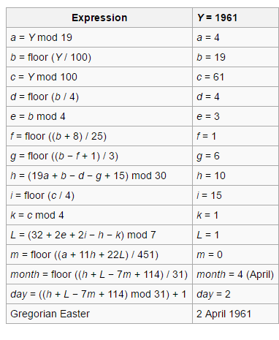
3 = March
4 = April
Try to develop this algorithm in Excel and calculate Easter for 2016 as a check. What date will Easter Sunday be in 2017?

